# **DBMS PRACTICAL FILE**

*Made By Akanksha Datyal*

*02-IT-18*

Ques 3: Exercises on Computations on table data:

1. Find the names of all clients having ‘a’ as the second letter in their names.

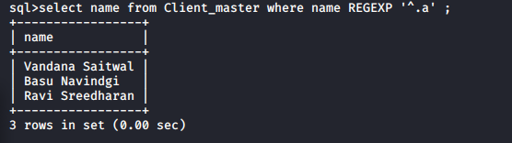

1. Find out the clients who stay in the city whose second letter is ‘a’.

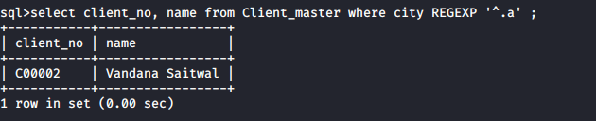

1. Find the list of all cients who stay in ‘Bombay’ or Delhi.

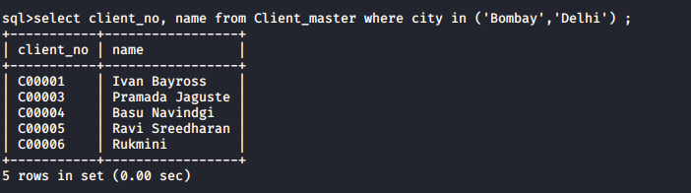

1. Print the list of clients whose bal_due is greater than value of 10000.

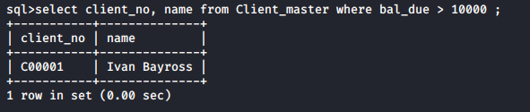

1. Print the information from the sales_order table for orders placed in the month of January.

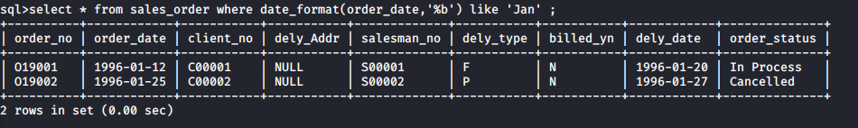

1. Display the order information for client no ‘C00001’ and ‘C00002’.

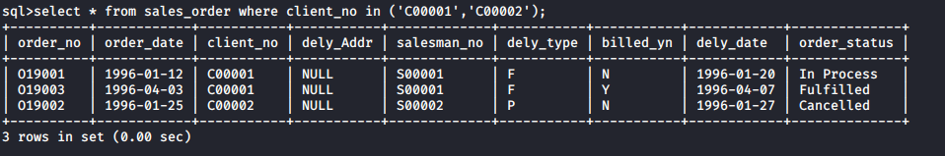

1. Find the products whose selling price is greater than 2000 or less than or equal to 5000.

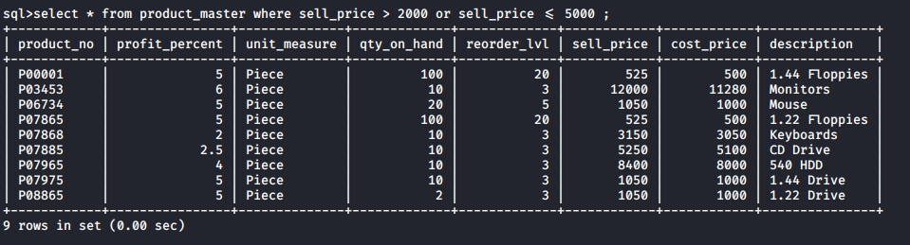

1. Find the products whose selling pirce is more than 1500. Calculate a new selling price as,

Original selling price * 0.15. Rename the new cloumn in the above query as new_price.

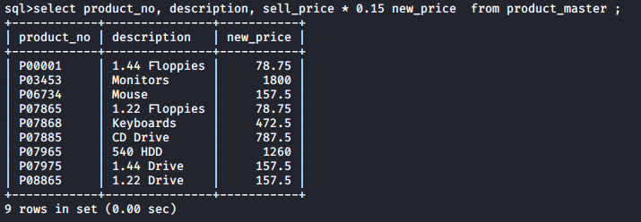

1. List the name,city and state of the clients who are not in the state of ‘Maharashtra’.

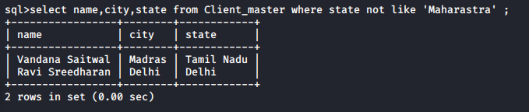

k) Calculate the average price of all products.

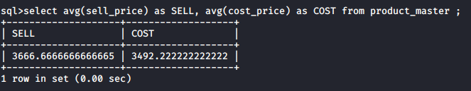

l) Determine the max and min product prices. Rename the output as max_price and min_price resp.

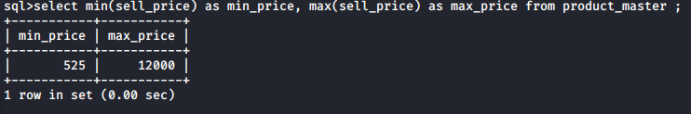

m) Count the number of products having price greater than or equal to 1500.

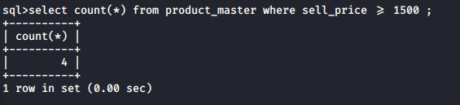

n) Find all the products whose qty_on_hand is less than reorder level.

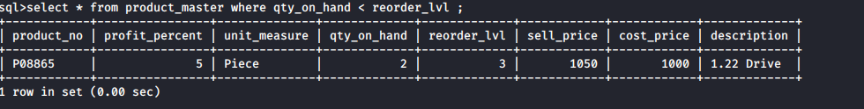

Ques 4) Exercise on Date Manipulation.

1. Display the order number and day on which clients placed their order.

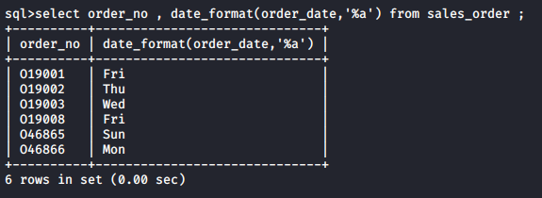

1. Display the month (in alpha) and date when the order must be delivered.

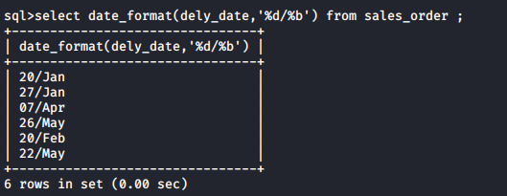

1. Display the order_date in the format ‘DD-Month-YY’.

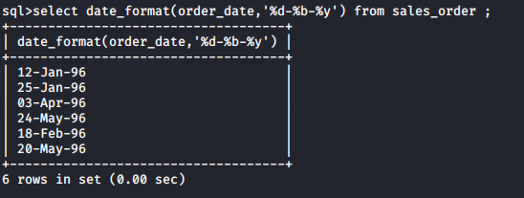

1. Find the date, 15 days agter today’s date.

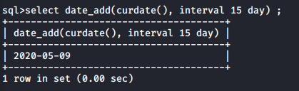

1. Find the number of days elapsed between today;s date and the delivery date of the orders placed by the client.

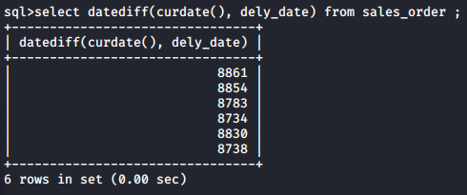

Ques 5) Exercises on using having and group by clauses:

1. Print the description and total qty sold for each product.

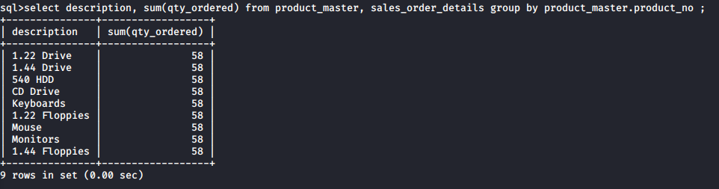

1. Find the value of each product sold.

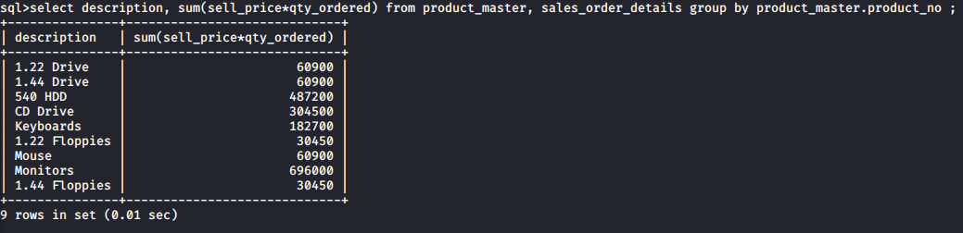

1. Calculate the avg qty sold for each client that has maximum order value of 15000.

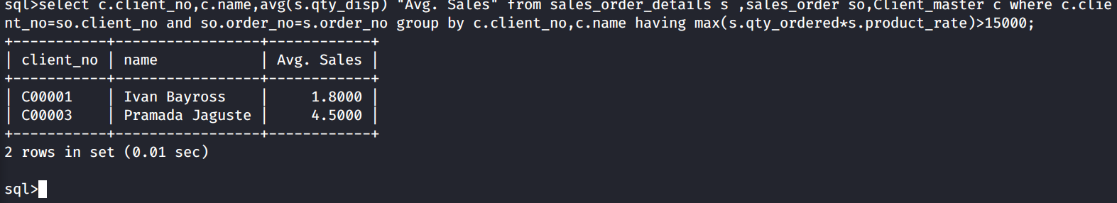

1. Find out the sum total of all the billed orders for the month january.

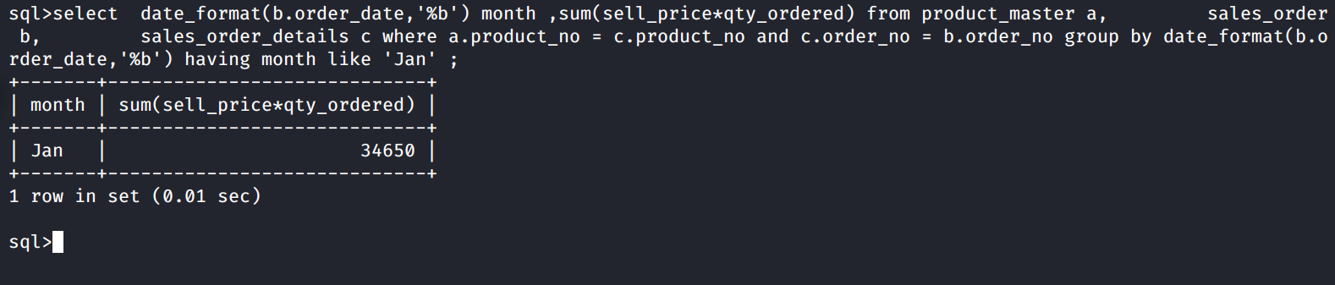

Ques 6: Exercises on Joins and Correlations:

1. Find out the products which have been sold to ‘Ivan Bayross’

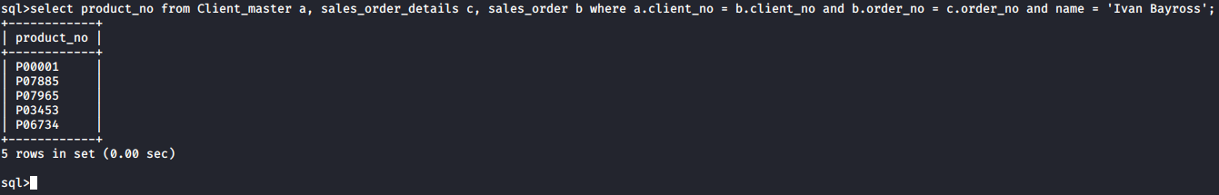

1. Find out the products and their quantities that will have to be delivered in the current month.

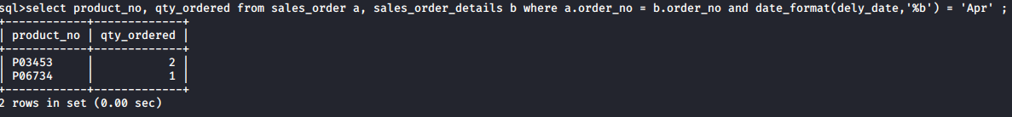

1. Find the product_no and description of constantly sold items.
2. Find the names of the clients who have purchased ‘CD Drive’.

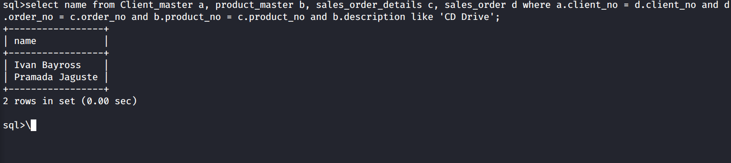

1. List the products_no and order_no of customers having qty_ordered less than 5 from the sales_order_details table for product ‘1.44 Floppies’.

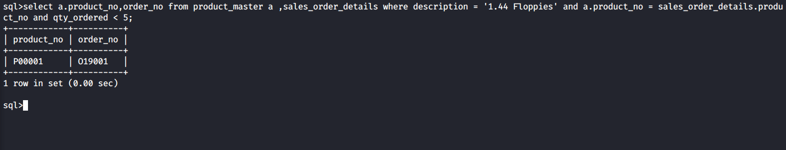

1. Find the products and their quantities for the orders placed by client_no ‘C00001’ and ‘C00002’.

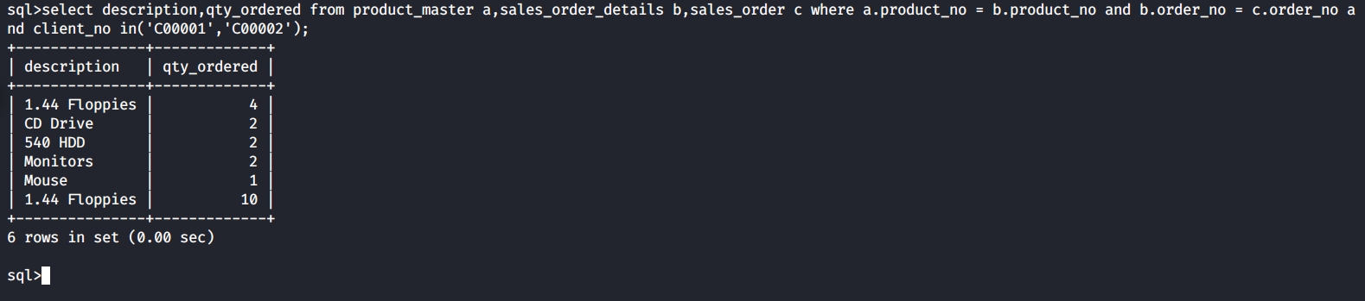

1. Find the product and their quantity for the orders placed by ‘Ivan Bayross’ and ‘Vandana Saitwal’.

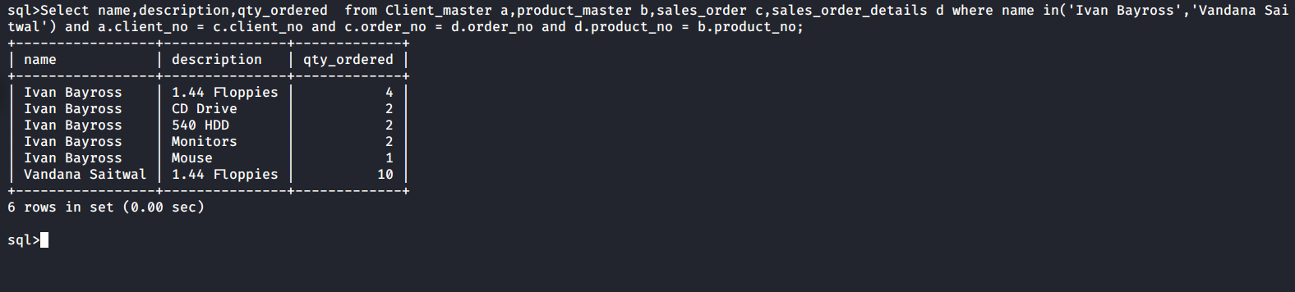

Ques 7) Exercise on Subqueries:

1. Find the product no. and description of non moving products i.e. not being sold

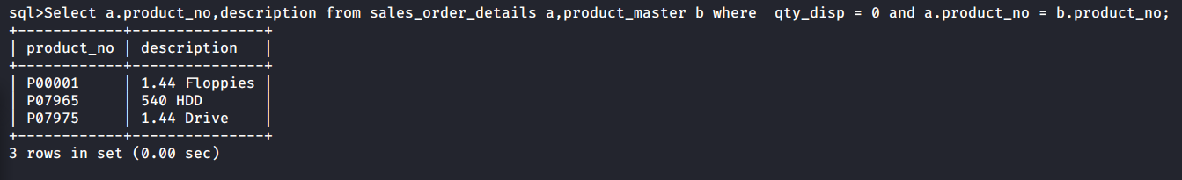

1. Find the customer name, address1,address2.city and pincode for the client who has placed order no. ‘O19001’.

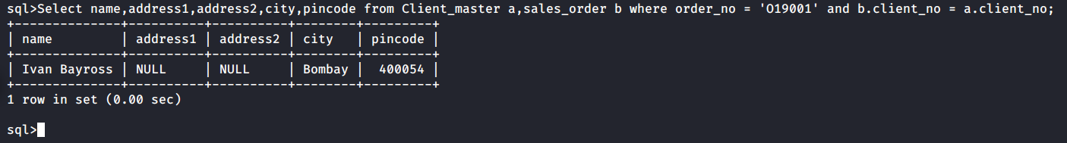

1. Find the client name that has placed orders before the month of May’09.

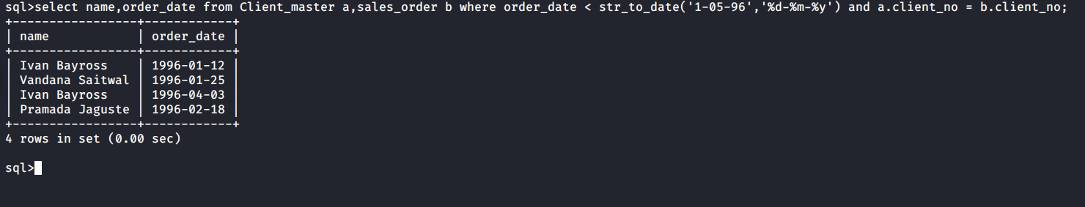

1. Find out if the product ‘1.44 Drive’ has been ordered by any client and print the client_no, name to whom it was sold.

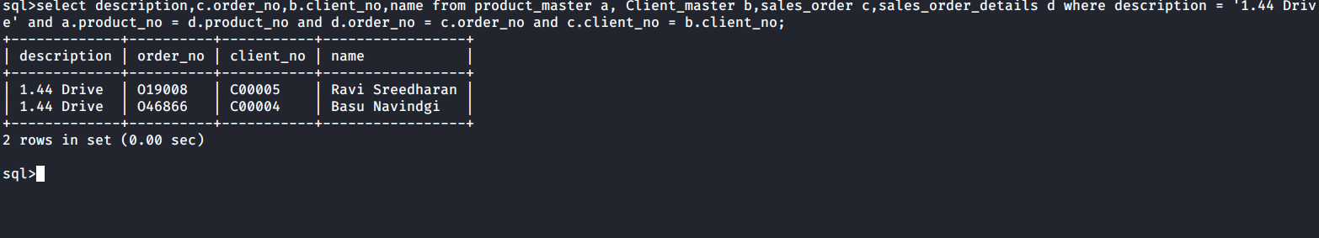

1. Find names of the clients who have placed orders worth Rs. 10000 or more.

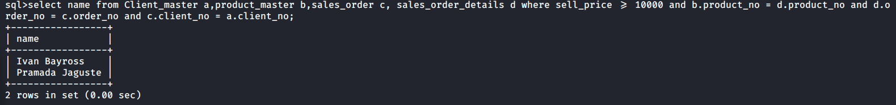

Ques 3) Exercise on retrieving records from the table:

1. Find out the names of all the Clients.

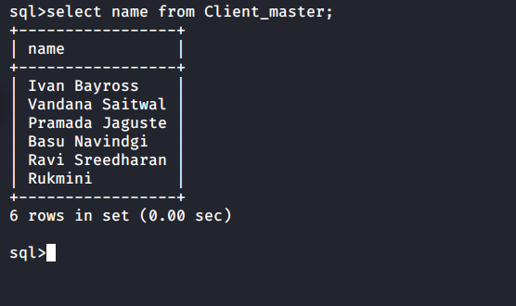

1. Retrieve the entire contents of the client_master table.

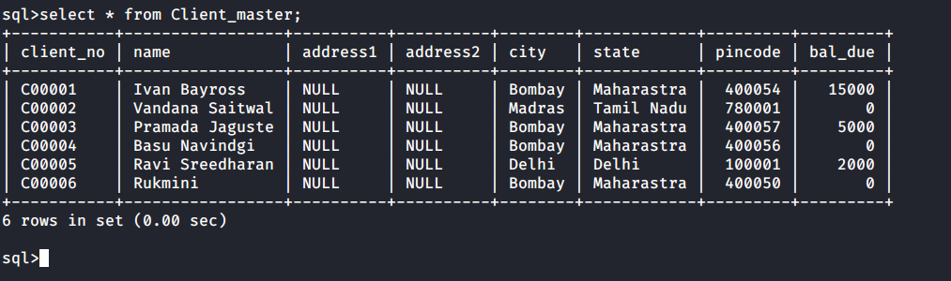

1. Retrieve the list of names and cities of all the clients.

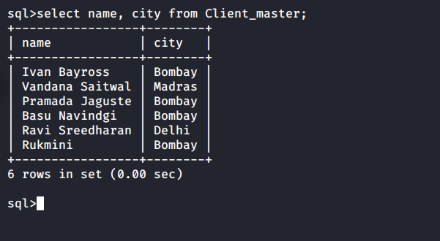

1. List the various products available from the product_master table.

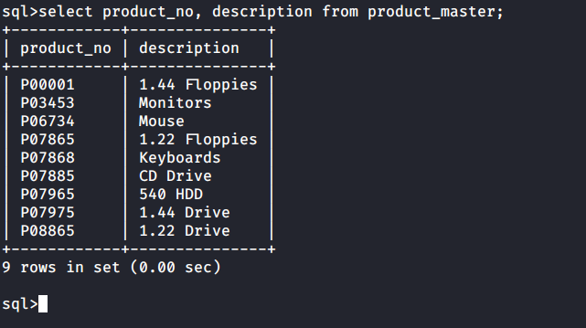

1. List all the clients who are located in Bombay.

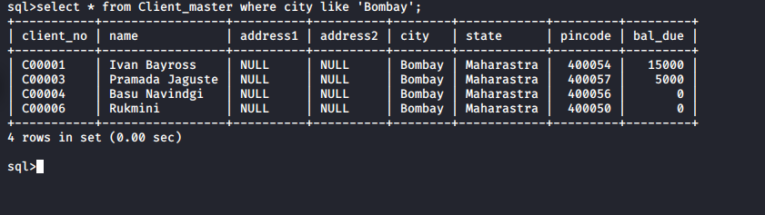

1. Find the names of the salesman who have salary equal to Rs 3000.

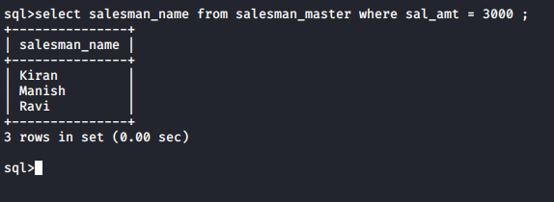

Ques 4) Excercise on Updating records in a table.

1. Change the city of Client_no ‘C00005’ to ‘Bombay’.

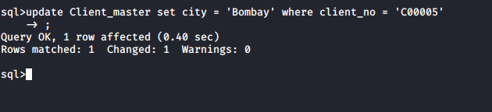

1. Change the bal_due of client_no ‘C00001’ to Rs 1000.

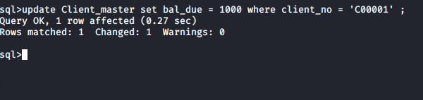

1. Change the cost price of ‘1.22 Floppy Drive’ to Rs 950.00

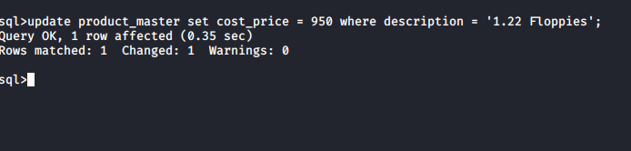

1. Change the city of the salesman to Mumbai.

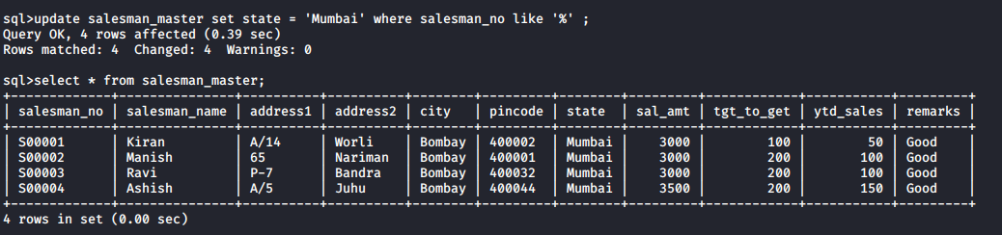

Ques 5) Excercise on deleting records in a table:

1. Delete all Salesman from the Salesman_master whose salaries are equal to Rs 3500.

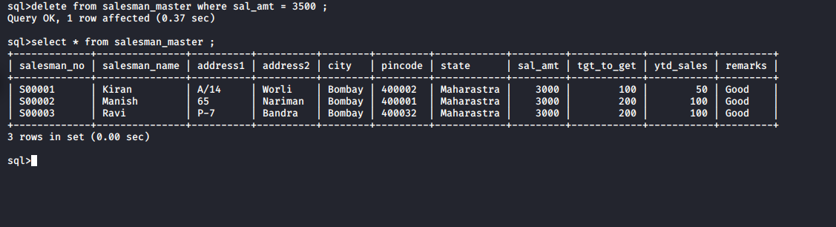

1. Delete all products from products_master where quantity on hand is equal to 100.

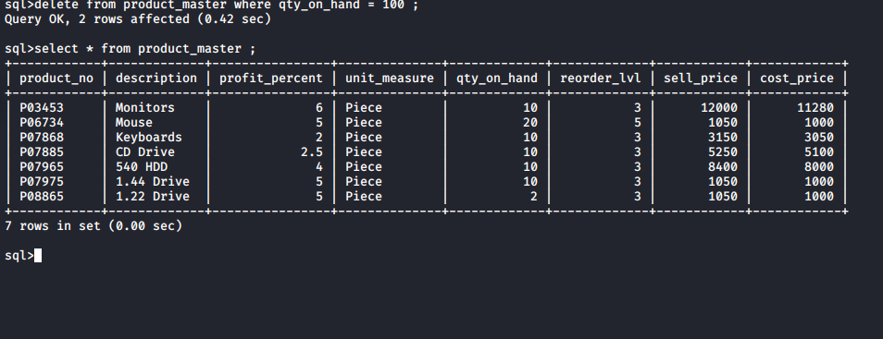

1. Delete from Client_master where the columns state holds the value ‘Tamil Nadu’

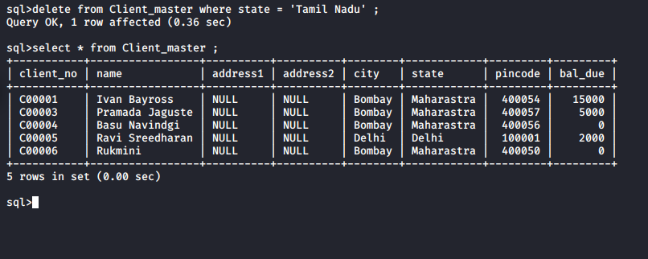

Ques 6) Exercise on Altering the table Structure.

1. Add a column called telephone of data type number and size 10 to client_master table.

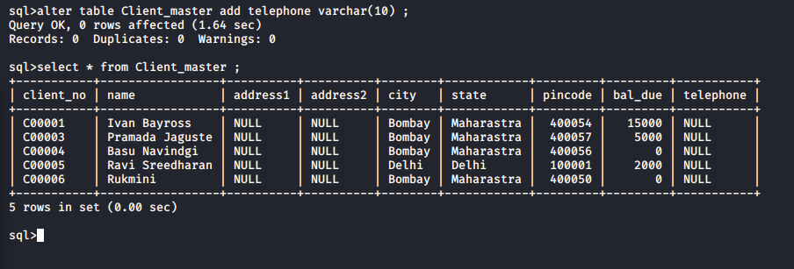

1. Change the size of sell_price column in product_master to 10,2.

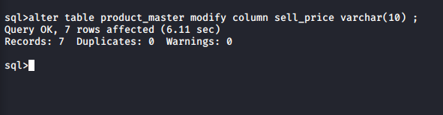

Ques 7) Exercise on deleting the table structure along with the data.

1. Destroy the table client_master.

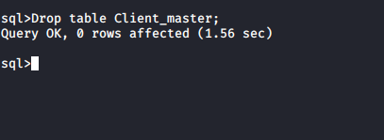

Ques 8) Exercise on renaming the table.

1. Rename salesman_master to sman_mast.

